Q1. (a) Give a term that related to upper sublayer of layer two and briefly describe that term. (3 marks)

The upper sublayer of layer two is referred to as Logical Link Control or LLC:

Description of LLC:

* Defined as IEE 802.2
* Driver of the NIC
* Defines the software processes that provides services to the network layer protocols.

(b) The following figure shows a frame of data link layer.

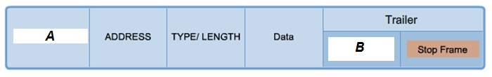

Figure 1: A structure of a frame

1. Identify a header of a frame that labeled as “A” from Figure 1 and state the function of that flag.
   1. “A” indicate start frame. It is used to identify the beginning of the frame. (2 marks)
2. Based on Figure 1, identify a frame trailer that had indicated as “B”. List a role of that flag.

“B” refers to Error Detection fields or Frame check sequene (FCS). The field is used for error checking. (2 marks)

(c) Protocol Data Unit (PDU) of a message in Data Link Layer is called frame. A frame consists of three portions. There are referred to header, data and trailer.

1. Name a protocol of Data Link Layer. (1 mark)
2. Any of the following Layer 2 protocol: -
   1. Point to point protocol (PPP)
   2. IEEE 802.11 wireless
   3. High level data link control (HDLC)
   4. Frame relay
   5. IEEE 802.3 Ethernet
3. Identify a sublayer of Data Link Layer that defines the media access processes performed by the hardware. (1 mark)
   1. Media Acces Control (MAC)
4. Identify and briefly describe **TWO (2)** fields that related to the header of a frame. (6 marks)

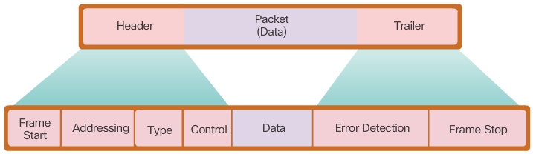

* Fields in the header of a frame are: -
  + Frame start – Used by the MAC sublayer to identify the beginning of the frame.
  + Addressing – Indicaate the source and destination nodes in the media.
  + Type – Identifies the Layer 3 protocol in the data field
  + Control – Identifies special flow control services suc as quality of service (QoS). QoS is used to give forwarding priority to certain types of messagse. Data link frames caarrying voice over IP (VoIP) packets normally receive priority because they are sensitive-to-delay

1. What is the purpose of stop frame that located at the trailer of a frame? (2 marks)
   1. It indicates the end of the frame when transmitted

Q2. Briefly describe the features of a controlled access method. *(201505 TAR UC, resit)* (8 marks)

* When using the controlled access method, network devices take turns, in sequence, to access the medium
* If an end device does not need to access the medium, then the opportunity passes to the next end device.
* This process is facilitated by use of a token.
* An end device acquires the token and places a frame on the media, no other device can do so until the frame has arrived and been processed at the destination, releasing the token.

Q3. (a) The Figure 2 shows a network topology on how computers can communicate across LAN and WAN via different types of physical media and Layer 2 protocols. Answer the following question based on the Figure 2.

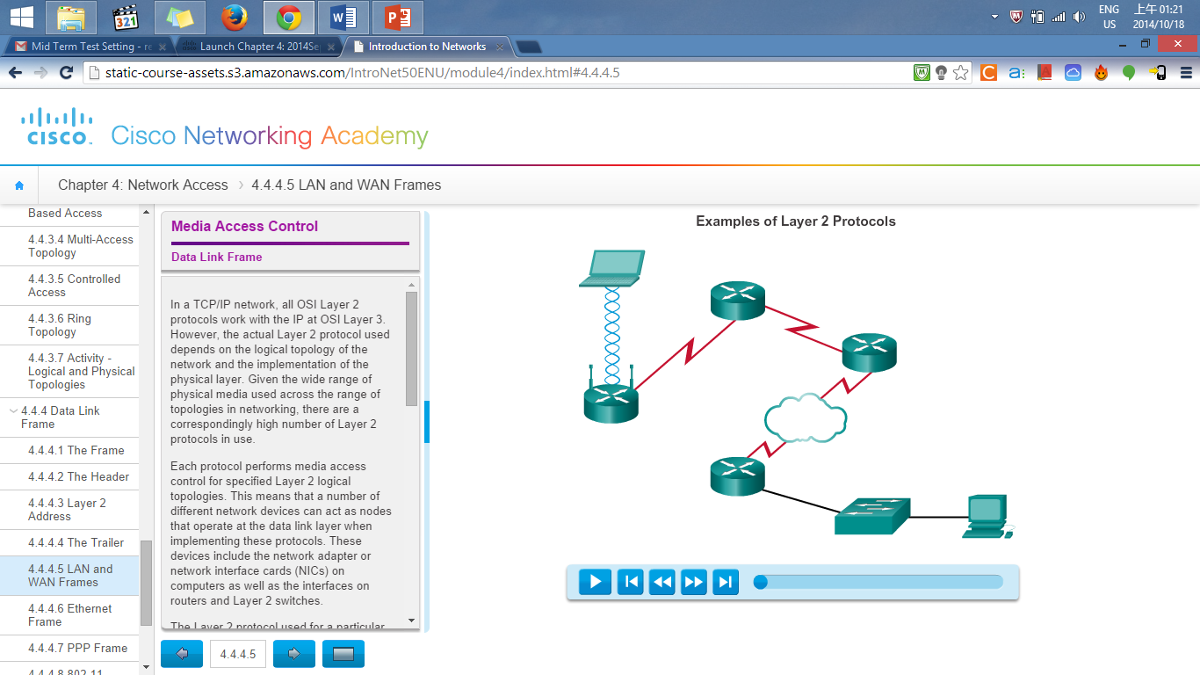

HDLC

A

PPP

Frame Relay

B

Figure 2

1. “A” and “B” are two different popular network connection methods for LAN. Identify the type of connecting media and the IEEE Networking Standard of LAN “A” and “B” respectively. (4 marks)

|  |  |  |
| --- | --- | --- |
| **Label** | **Connecting media** | **IEEE Networking Standard** |
| A | Wireless/EM wave (1m) | 802.11 Wireless LAN (1m) |
| B | Copper Cable/UTP (1m) | 802.3 Ethernet (1m) |

1. There are two types of access method in LAN topology. Which access method is used for both “A” and “B”? (1 mark)

* Contention-Based Access Method (1m) (Fore wireless and ethernet use contention)

1. Explain the types of access method mentioned in Q2(a)(ii). (6 marks)

|  |  |
| --- | --- |
| Characteristics | Contention-Based Technologies |
| * Station can transmit any time * Collision exist * There are mechanisms to resolve contention for the media | * CSMA/CD for 802.3 Ethernet networks * CSMA/CA for 802.11 wireless networks |

* To prevent collissions, carrier sense media access is used to resolve conflicts.
* If a carrier signal on the media from another node is detected, it means that another device is transmitting. When the device attempts to transmit sees that the media is busy, it will wait and try again after a short time period. If no carrier signal is detected, the device transmits its data.
* Ethernet and wireless networks use contention-based media access.
* It is possible that the CSMA process will fail and two devices will transmit at the same time creating a data collision. If this occurs the data sent by both devices will be corrupted and will need to be resend.

(b) What are the **TWO (2)** basic services of the Data Link Layer? (4 marks)

Data link layer performs these two basic services.

* It accepts Layer 3 packets and packages them into data units called frames.
* It controls media access control and performs error detection.

(c) If the data link layer didn’t exist, what changes would be required of a network layer protocol such as Internet Protocol (IP)? (6 marks)

* Without a data link layer, IP or other network layer protocols would need to make provisions for connecting every type of media that could exists along the delivery path.
* Moreover, IP would need to change every time a new network technology or medium were developed
* The disadvantage is avoided by using a layered model for networking and by giving the data link layer the job of placing data on a medium and controlling access to the medium.